Authors:

Group 18

Thomas Koh 329888

Vishall Krishnan XXX

Shaohua Liu 1150336

Yujing Yang XXX

Abstract

The planetary boundary layer (PBL) height is an important factor for measuring the pollution level of a given area. The DPIE have asked us to conduct an analysis comparing the PBL height values based on two different sources, the CL51 ceilometer and the CT model output. This report shows our preliminary exploratory data analysis conducted on the data and our proposal going forward

Comparison of pbl height based on cl51 ceilometer and ct model outputs in merriwa and lidcombe

An EDA analysis and scoped proposal

Contents

A. Introduction 2

Background: 2

Problem statement: 2

Intended outcomes of analysis: 2

B. Related work (Yujing) 3

C. Data analysis and preliminary modelling 4

Data provided: 4

Data pre-processing steps. 4

D. Analysis 1 - Comparing the PBL height of both datasets. 6

Visualisation of the CL51 and CTM PBL height data 6

Statistical metrics 8

Discussion 9

E. Analysis 2 - Analysing factors that impact the PBL heights 10

Statistical metrics 10

Visualization of PBL height with the external factors 10

Comparing PBL heights against external factors in both locations 10

Comparing PBL heights against external factors in Merriwa 11

Comparing PBL heights against external factors in Lidcombe 12

F. Proposal for Semester 2 14

G. Proposed timeline for Semester 2 14

H. References 15

Appendix A: Details on dataset provided 16

Appendix B: Formulae for statistical metrics 17

Appendix C: Description of external factors considered 19

Appendix D: Correlation tables between PBL heights and external factors 20

## Introduction

### Background:

There has traditionally been a lot of pollution in New South Wales (NSW) due to mining in particular from mining dust. As such, there has been concerted effort to better monitor these pollution sites. As part of this effort The Department of Planning, Industry and Environment of the NSW Government (DPIE) have obtained new instruments as part of an industry programme to monitor pollution levels.

One such instrument is the CL51 ceilometer by Vaisala which is an air quality measurement tool. This is rolled out in two locations: (1) Merriwa and (2) Lidcombe. We have therefore been asked to investigate the efficacy of a new air quality measuring tool in measuring pollution levels in these two areas.

### Problem statement:

We have been notified by DPIE that the Planetary Boundary Layer Height (PBL height) is an important factor for measuring the pollution level of a given area.

We have subsequently been tasked to compare the quality of the PBL height as measured by the new CL51 ceilometer instrument. In doing so we aim to answer the following questions:

* How accurate and reliable is the PBL height data as obtained from the CL51 ceilometer;
* How do the readings from the CL51 ceilometer compare to the predicted PBL height as obtained from the CT model; and
* What are the potential improvements that can be made to the prediction of PBL height based on information obtained from the CL51 ceilometer.

For each of the two locations, we are presented with the following information:

* CL51 data for the period from 12/2/2021 to 19/2/2021; and
* Predicted PBL height values;

### Intended outcomes of analysis:

In Semester 1, our focus was on performing detailed exploratory data analysis on the PBL height data provided. The intended outcome of the analysis is as follows:

* To develop metrics for comparing the PBL height from the CL51 ceilometer against the predicted PBL height data from the CT model output; and
* To understand the factors that drive the change in PBL height.

## Related work (Yujing)

## Data analysis and preliminary modelling

In this section we outline the results of our preliminary analysis of the PBL height data provided.

### Data provided:

DPIE has provided the following PBL height data for the period between 12/2/2021 to 19/2/2021 at Merriwa and Lidcombe:

* Data from the Viasala CL51 ceilometer; and
* Data from the CT model.

Both dataset are provided in the form of CSV files.

Detailed values and description of the dataset provided is set out in Appendix A.

### Data pre-processing steps.

We have used Python to pre-process the data. The following sets out the detailed steps taken to pre-process both datasets provided.

#### Pre-processing the CL51 dataset.

1. Data is firstly loaded into Python.
2. We notice that missing values in the CSV files are automatically filled with “-999”. This is changed into ‘NaN’ values for ease of future processing.
3. A proper datetime stamp is created based on information already present in the data.
4. Imputation is performed on the “bl_height” feature to append the missing values. We have chosen to impute the missing values (as opposed to omitting the data with missing values) because we have limited data to work with (i.e. only one week’s worth of observations). We have used the Pandas library’s built-in interpolation method (interpolated based on the datetime stamp).

#### Pre-processing the CT model data.

1. Data is again similarly loaded into Python.
2. We note that the “time” field recorded in this dataset is in UTC. We have adjusted this datafield to align the timestamp with the CL51 data which is in AEST. This is done by adding 10 hours to the data in the “time” field.
3. A datetime stamp is then created using the revised “time” field as described above.

#### Aligning the two datasets.

We further note that the granularity of the CL51 dataset datetime stamp is in seconds, whereas the granularity of the CT model output datetime stamp is in hours.

To make the two datasets comparable, we have grouped the CL51 dataset such that it has the same datetime stamp granularity as the CT model outputs (i.e. hours as opposed to minutes). As such in the grouped CL51 dataset, the PBL height at each hour reflects the average PBL height within that hour from the original dataset.

This is then combined with the pre-processed CT model data and used for comparisons.

#### Comparing the CL51 datasets before and after pre-processing

The following graphs show the PBL height as obtained from the CL51 ceilometer in Merriwa and Lidcombe before and after the datasets were imputed.

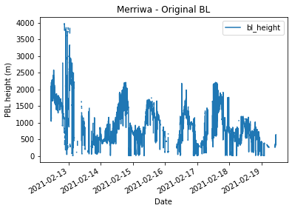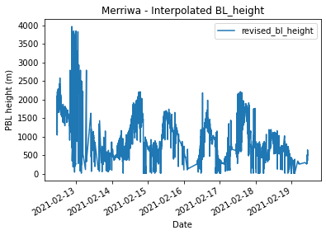

Figure 1 Original vs interpolated PBL heights in Merriwa

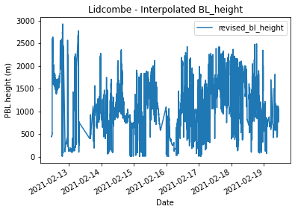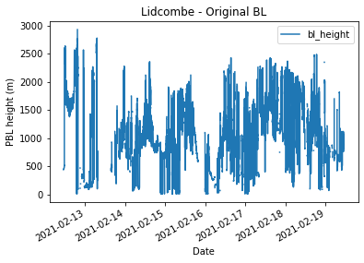

Figure 2 Original vs interpolated PBL heights in Lidcombe

We observe that the pre-processing has successfully filled in the gaps in the missing values in both locations. We further note that based on visual inspection, the method of interpolating the data between datetime stamps is an appropriate in these circumstances given the granularity of the data originally provided.

## Analysis 1 - Comparing the PBL height of both datasets.

In this section we consider a detailed exploratory data analysis of the PBL height as presented in both the CL51 and CT model output datasets.

This section is divided into two parts:

1. Visual comparisons of the CL51 and CTM PBL height data; and

2. Derivation of statistical metrics for comparison of both datasets.

### Visualisation of the CL51 and CTM PBL height data

We firstly denote the CL51 PBL height as the actual PBL height observed in an area. Consequently, the CT modelled PBL height is then denoted as the predicted PBL height.

The following graphs show a comparison between the CL51 (actual) PBL height and the CT model (predicted) PBL height at both locations.

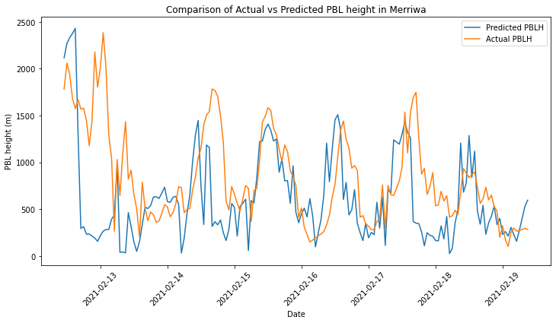

Figure 3 Actual vs Predicted PBL height in Merriwa

Overall, in Merriwa we observe that there is quite a tight overlap between predicted and actual PBL height over the one-week period.

We note however observations in the timeframe from 12/2/2021 to 13/2/2021 deviate significantly. This is due to poor quality readings from CL51 ceilometer which may be as a result of rain during this period.

From midday 13/2/2021 to around midday 17/2/2021 the CT model outputs was in agreement with the actual observed PBL height. There is then another discrepancy in readings from midday 17/2/2021 to 18/2/2021. Unsure as to why this is the case

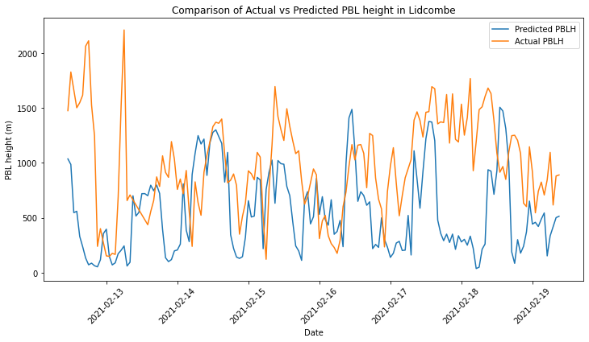

Figure 4 Actual vs Predicted PBL height in Lidcombe

In Lidcombe however, the CT model outputs and CL51 ceilometer readings exhibit significantly more deviations.

We observe that while there is some agreement as to the timing of the peaks and troughs of the PBL height as measured by the CT model and the CL51 ceilometer, their magnitudes are vastly different. For instance, the actual versus predicted PBL heights at 13/2/2021 and again from 17/2/2021 to 18/2/2021 are in total opposition to one another.

The following graphs compares the PBL height at each hour of the day grouped by the date of the observations.

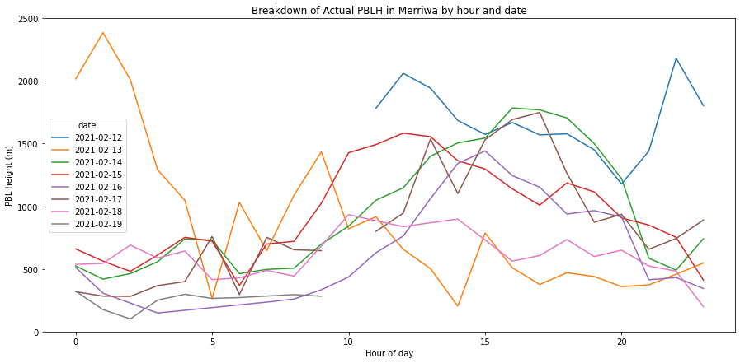

Figure 5 Breakdown of actual PBL height in Merriwa by hour

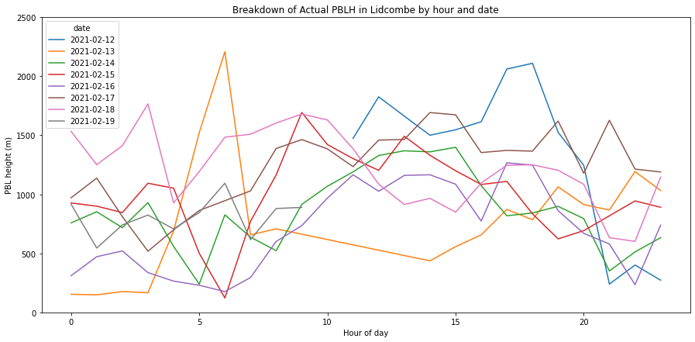

Figure 6 Breakdown of actual PBL height in Lidcombe by hour

The above graphs further highlight the cyclic nature of the PBL height. We observe that the PBL height tends to reach peak height during the middle of the day (at around 3pm) before dropping off again and troughing at around 5 am.

### Statistical metrics

In addition to visual inspections, we have also calculated some select statistical metrics aimed at comparing the fit between the actual PBL height and the predicted PBL height. To do this, we have selected 5 metrics which are as follows:

* Wilmot’s index of agreement;
* Root mean squared error (RMSE);
* Mean absolute error;
* Mean bias error; and
* DTW distance

A detailed derivation of the statistical measures used and their interpretations are set out in Appendix A.

The following sets out a summary of the statistical metrics measured for both locations:

|  |  |  |
| --- | --- | --- |
|  | **Location** | |
|  | **Merriwa** | **Lidcombe** |
| Wilmot's Index of agreement | 0.64061 | 0.47060 |
| RMSE | 597 | 684 |
| Mean absolute error | 416 | 540 |
| Mean bias error | -233 | -430 |
| DTW distance | 91,526 | 107,124 |

The measures indicate that there is a closer fit between the actual and predicted PBL heights in Merriwa compared to Lidcombe.

### Discussion

The PBL height exhibits a peak and trough type behaviour where peaks are typically around midday and troughs are late at night/early mornings. Overall, there is a fairly reasonable correlation between the predicted and actual PBL over the one-week period. The CT model was able to capture the behaviour of the PBL height in both locations.

There are however significant deviations in the quality of the predicted PBL height from the CT model as compared to the actual PBL heights from the CL51 ceilometer in both locations. In particular, we note that in Merriwa the CT model outputs tend to match the actual PBL height much more closely than in Lidcombe.

While we offer no concrete reasons as to why this is the case, we reason that this may be driven in large part by the urban and geographic environment of the two sets of observations. Lidcombe, being an inner suburb within the Sydney Metropolitan area, is subject to constant pollution and disturbances from urban infrastructure that may potentially impact the reading of the ceilometer. Merriwa by contrast, is located in the Hunter Valley where there are little disturbances from urban infrastructures.

## Analysis 2 - Analysing factors that impact the PBL heights

In this section we analyse external factors that potentially influence the actual and predicted PBL heights in both locations. The set of external factors considered in this analysis is set out in Appendix A.

### Statistical metrics

When comparing the PBL heights against the external factors, we have used two statistical measures:

* Pearson’s correlation; and
* P-value.

We use the above measurements to check each external factor’s correlation with predicted and actual PBL height and p-value. A detailed description of the formulae is set out in Appendix A.

The correlation tables for each location against the external factors are set out in Appendix B.

### Visualization of PBL height with the external factors

In addition to the statistical metrics, plots were also done to validate the correlation calculated between the boundary layer heights and the various external factors. The plots are done in two-fold by comparing the PBL heights with:

1. Factors relating to weather such as rainfall, temperature etc.
2. Factors relating to the chemical particles present in the atmosphere such as carbon monoxide, sulphur dioxide etc.

The plots of the PBL heights and the external factors are used to validate the statistical inferences inferred below.

### Comparing PBL heights against external factors in both locations

We observe that external factors of carbon monoxide, humidity, nephelometer, ozone, temperature, wind direction sigma theta and solar radiation have an influence on the PBL heights in both locations.

Specifically:

* Humidity has a negative correlation with actual PBL height;
* Nitrogen dioxide has a negative correlation with predicted PBL height;
* Moreover, wind speed(10m) and solar radiation have positive correlation with predicted PBL height.

However, wind direction sigma theta shows contrary relations. To be more specific, there is a weak negative correlation with predicted PBL height but a weak positive correlation with actual PBL height.

Last but not the least, nitrogen dioxide and wind speed (10m) are not correlated with the actual PBL height of CL51 (as measured by their p-values), but these external factors are correlated with predicted PBL height of CT model.

### Comparing PBL heights against external factors in Merriwa

We observe that humidity remains strongly negatively correlated with PBL heights. Meanwhile, ozone and temperature remain strongly positively correlated with PBL heights. However, these are contrary to the overall analysis.

Specifically:

* Carbon monoxide is positively correlated to PBL heights in Merriwa;
* Wind direction sigma Theta has no relationship with PBL heights in Merriwa;
* Furthermore, nitrogen dioxide and rainfall remain not correlated with the actual PBL height (as measured by their p-values) but they have a weak correlation with predicted PBL height of CT model.

Since solar radiation information is not available for Merriwa, no conclusion can be drawn with respect to this external factor.

The following plots show the plots of comparing the PBL heights with the external factors in Merriwa.

* A picture containing chart

  Description automatically generatedA picture containing chart

  Description automatically generatedHumidity is shown to be strongly negatively correlated with the PBL heights.

Figure 7 Actual and Predicted PBL vs humidity in Merriwa

* Ozone is shown to be strongly positively correlated with the BL heights.

Figure 8 Actual and Predicted PBL vs Ozone in Merriwa

* Temperature is shown to be positively correlated with the PBL heights.

Figure 9 Actual and Predicted PBL vs temperature Merriwa

### Comparing PBL heights against external factors in Lidcombe

The statistical metric of Lidcombe indicates humidity remains negatively correlated with PBL heights in Lidcombe. Besides, solar radiation remains a strong positive correlation with predicted PBL heights. Temperature remains positively correlated with actual PBL heights. Additionally, nitrogen dioxide is not significantly correlated with the actual PBL height (as measured by their p-values) but is however significantly correlated with predicted PBL height of the CT model.

The following plots show the plots of comparing the PBL heights with the external factors in Lidcombe.

* Humidity is shown to be negatively correlated with the PBL heights.

CL51
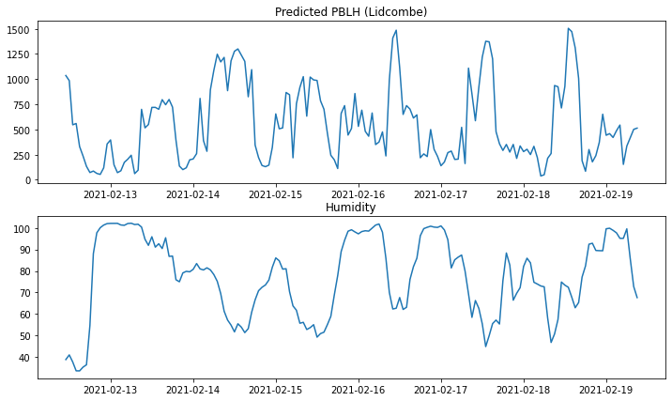

Figure 10 Actual and Predicted PBL vs humidity in Lidcombe

* Solar radiation is shown to be positively correlated with the PBL heights.

Figure 11 Actual and Predicted PBL vs solar radiation in Lidcombe

* Temperature is shown to be positively correlated with the PBL heights.

Figure 12 Actual and Predicted PBL vs temperature in Lidcombe

* Nitrogen dioxide is negatively correlated with the predicted PBL height but is not very correlated with the actual BL height.

Figure 13 Actual and Predicted PBL vs nitrogen dioxide in Lidcombe

## Proposal for Semester 2

Semester 2 will focus on the continuation of Analysis 2. In particular:

1. Further in-depth analysis of the factors that drive PBL height;
2. Derivation of model(s) that may be used to predict the PBL height based on such factors; and
3. Analysis of our derived model against: (1) the original PBL height data provided and (2) CT model output provided.

We also aim to provide a report summarizing our findings for DPIE.

## Proposed timeline for Semester 2

|  |  |  |
| --- | --- | --- |
| Task | Timeline in Semester 2 | Doer |
| Further in-depth analysis of factors that drive the PBL height | Weeks 1 – 2 |  |
| Derivation of models to predict the PBL height based on these factors | Weeks 1 – 4 |  |
| Analysis of models developed against CL51 data | Weeks 3 – 5 |  |
| Analysis of models developed against the CT model output | Weeks 3 – 5 |  |
| Consultations with DPIE in relation to our findings | Week 6 |  |
| Further revisions to the modelling based on feedback from DPIE | Weeks 6 – 9 |  |
| Final write-up of report and findings | Weeks 9 – 12 |  |
| Further consultations with DPIE as required | Weeks 10 – 11 |  |
| Final presentation of reports and findings to DPIE and cohort | Weeks 11 – 12 |  |

## References

Stub

## Appendix A: Details on dataset provided

In respect of the CL51 dataset:

|  |  |
| --- | --- |
| **Data fields** | **Description** |
| # Time | Datetime stamp of the observation in AEST |
| Layer_QualityIndex | Quality of information read |
| bl_height | PBL height in metres |
| Mean_Layer_Height | Mean of the PBL height in metres |
| n_BL | Number of PBL observed |
| cloud_stat | Number of cloud layers observed |
| cloud_dat | Height of cloud data in metres |

In respect of the CT model dataset:

|  |  |
| --- | --- |
| **Data fields** | **Description** |
| lat | Latitude of observed location |
| lon | Longitude of observed location |
| date | Date of observation |
| time | Time of observation in UTC |
| temperature | Predicted temperature in Celsius |
| mixing_height | Predicted PBL height in metres |

## Appendix B: Formulae for statistical metrics

As a matter of convenience, we will adopt the following notations:

|  |  |
| --- | --- |
| Notation | Description |
|  | Actual PBL height observed at a particular location at time *i.*  This corresponds to dataset obtained from the CL51 ceilometer. |
|  | Predicted PBL height observed at a particular location at time *i.*  This corresponds to dataset obtained from the CT model output. |
|  | The average actual PBL height observed at a particular location based on the CL51 ceilometer data. |
|  | The average predicted PBL height observed at a particular location based on the CT model output. |
|  | Number of observations |
|  | The value of the external factor observed at a particular location at time *i.* |
|  | The average value of the external factor observed at a particular location at time *i.* |

The following statistical measures have been used in Sections D and E.

|  |  |
| --- | --- |
| **Statistical measures** | **Description of measure** |
| Wilmott’s Index of Agreement | A numeric measure that measures how well a model simulates observed data. Simulations that fit the observed data well will exhibit higher index of agreement values.  The formula is given as follows: |
| Root mean squared error (RMSE) | Measures the root of the average squared difference between the actual and predicted PBL height at a given area. This is a proxy measure for the distance between the actual and predicted PBL heights. This metric naturally gives precedence to larger deviations between the actual and predicted PBL heights.  The formula is given as follows: |
| Mean absolute error | Measures the average absolute difference between the actual and predicted PBL height at a given area. This is another proxy measure for the distance between the actual and predicted PBL heights. Contrary to RMSE, this measure is not skewed by larger deviations between the actual and predicted PBL heights.  The formula is given as follows: |
| Mean bias error | Measures the average difference between the actual and predicted PBL height at a given area.  The formula is given as follows: |
| Dynamic Time Warping (DTW) distance | DTW presents an alternative metric for measuring the distance between the actual and predicted PBL heights.  In contrast to the RMSE, DTW attempts to find the best mapping between the actual and predicted PBL heights such that the distance between the mappings is minimised. Such techniques are called time-warping. |
| Pearson correlation | Measures actual and predicted PBL height whether has a linear relationship with external factors.  For external factors and CL51 (actual) PBL Height:    For external factors and CT Model(predicted) PBL Height: |
| p-value | Measures the correlation between PBL height and external factors is significant or not.  The null hypothesis is coefficient of external factor is 0, which indicates the external factor has no relationship with actual or predicted PBL height.  If p-value less than 0.5, then we reject the null hypothesis and the correlation is statistically significant.  If the p-value is greater than 0.5, then we cannot conclude that the correlation is different from 0. |

## Appendix C: Description of external factors considered

The following table sets out the set of external factors that are analysed and a brief description of what they are:

|  |  |
| --- | --- |
| **External factors** | Description[1] |
| **Carbon monoxide** | Concentration of carbon monoxide in atmosphere reported in parts per million (ppm) |
| **Humidity** | Relative humidity in atmosphere measured as percentage of maximum humidity. |
| **Nephelometer** | Measure of visibility by measuring light scattering reported in 10-4 m-1 |
| **Nitric Oxide** | A principal form of oxides of Nitrogen that is commonly found in the atmosphere measured by pars per hundred million (pphm) |
| **Nitrogen Dioxide** | A form of oxides of Nitrogen that is also commonly found in the atmosphere measured by pphm |
| **Ozone** | A gaseous secondary pollutant that is found in the atmosphere measured by pphm |
| **PM10** | Fine particles of less than 10 micrometers (μm) in diameter found in the atmosphere measured by μg/m3 |
| **PM2.5** | Fine particles of less than 2.5 μm in diameter found in the atmosphere measured by μg/m3 |
| **Rainfall** | Amount of rainfall measured by mm/m2 |
| **Sulphur Dioxide** | A form of respiratory pollutant found in the atmosphere measured by pphm |
| **Temperature** | Temperature measured by Celsius |
| **Wind Direction (10m)** | Direction that the wind is blowing from measured in degrees |
| **Wind Direction Sigma Theta** | Standard deviation in the wind direction measured in degrees |
| **Wind Speed (10m)** | Wind speed measured in m/s |
| **Solar radiation** | Solar radiation of a given location measured by watts/m2 |

## Appendix D: Correlation tables between PBL heights and external factors

Both locations’ actual and predicted PBL height vs external factors:

|  |  |  |  |  |
| --- | --- | --- | --- | --- |
|  | correlation | | p-value | |
|  | CL51 | CT Model | CL51 | CT Model |
| **Carbon monoxide** | -0.28486 | -0.460941 | 0.001769 | 0 |
| **Humidity** | -0.576953 | -0.437755 | 0 | 0.000001 |
| **Nephelometer** | -0.313251 | -0.311381 | 0.000553 | 0.000599 |
| **Nitric Oxide** | 0.152507 | -0.249707 | 0.099213 | 0.006392 |
| **Nitrogen Dioxide** | -0.013995 | -0.60063 | 0.880438 | 0 |
| **Ozone** | 0.32864 | 0.399086 | 0.00028 | 0.000008 |
| **PM10** | 0.138696 | -0.119004 | 0.134177 | 0.19931 |
| **PM2.5** | -0.148077 | -0.148062 | 0.109546 | 0.109581 |
| **Rainfall** | -0.08885 | -0.193913 | 0.338681 | 0.035377 |
| **Sulphur Dioxide** | 0.070599 | -0.143544 | 0.447444 | 0.120966 |
| **Temperature** | 0.482661 | 0.187751 | 0 | 0.041758 |
| **Wind Direction (10m)** | 0.186592 | -0.118215 | 0.043059 | 0.202327 |
| **Wind Direction Sigma Theta** | 0.226398 | -0.226359 | 0.013692 | 0.013709 |
| **Wind Speed (10m)** | -0.034239 | 0.540128 | 0.712818 | 0 |
| **Solar radiation** | 0.389137 | 0.645485 | 0.000013 | 0 |

Actual and predicted PBL heights in Merriwa vs external factors:

|  |  |  |  |  |
| --- | --- | --- | --- | --- |
|  | correlation | | p-value | |
|  | CL51 | CT Model | CL51 | CT Model |
| **Carbon monoxide** | 0.522859 | 0.200391 | 0 | 0.011856 |
| **Humidity** | -0.755757 | -0.597379 | 0 | 0 |
| **Nephelometer** | -0.128754 | -0.089435 | 0.108036 | 0.265323 |
| **Nitric Oxide** | 0.05293 | 0.150851 | 0.510299 | 0.059313 |
| **Nitrogen Dioxide** | -0.104132 | -0.312676 | 0.194331 | 0.000067 |
| **Ozone** | 0.695825 | 0.497777 | 0 | 0 |
| **PM10** | 0.475645 | 0.091247 | 0 | 0.255725 |
| **PM2.5** | 0.078824 | -0.245054 | 0.326444 | 0.00198 |
| **Rainfall** | -0.065411 | -0.131461 | 0.415689 | 0.100763 |
| **Sulphur Dioxide** | 0.05669 | -0.046874 | 0.480677 | 0.559919 |
| **Temperature** | 0.692539 | 0.527734 | 0 | 0 |
| **Wind Direction (10m)** | 0.400062 | 0.127651 | 0 | 0.111114 |
| **Wind Direction Sigma Theta** | 0.005815 | 0.010209 | 0.942383 | 0.899019 |
| **Wind Speed (10m)** | 0.10997 | 0.399278 | 0.170352 | 0 |

Actual and predicted height in Lidcombe vs external factors:

|  |  |  |  |  |
| --- | --- | --- | --- | --- |
|  | correlation | | p-value | |
|  | CL51 | CT Model | CL51 | CT Model |
| **Carbon monoxide** | -0.28486 | -0.460941 | 0.001769 | 0 |
| **Humidity** | -0.576953 | -0.437755 | 0 | 0.000001 |
| **Nephelometer** | -0.313251 | -0.311381 | 0.000553 | 0.000599 |
| **Nitric Oxide** | 0.152507 | -0.249707 | 0.099213 | 0.006392 |
| **Nitrogen Dioxide** | -0.013995 | -0.60063 | 0.880438 | 0 |
| **Ozone** | 0.32864 | 0.399086 | 0.00028 | 0.000008 |
| **PM10** | 0.138696 | -0.119004 | 0.134177 | 0.19931 |
| **PM2.5** | -0.148077 | -0.148062 | 0.109546 | 0.109581 |
| **Rainfall** | -0.08885 | -0.193913 | 0.338681 | 0.035377 |
| **Solar radiation** | 0.389137 | 0.645485 | 0.000013 | 0 |
| **Sulphur Dioxide** | 0.070599 | -0.143544 | 0.447444 | 0.120966 |
| **Temperature** | 0.482661 | 0.187751 | 0 | 0.041758 |
| **Wind Direction (10m)** | 0.186592 | -0.118215 | 0.043059 | 0.202327 |
| **Wind Direction Sigma Theta** | 0.226398 | -0.226359 | 0.013692 | 0.013709 |
| **Wind Speed (10m)** | -0.034239 | 0.540128 | 0.712818 | 0 |

1. Obtained from: https://www.environment.nsw.gov.au/topics/air/understanding-air-quality-data/glossary-of-air-quality-terms